Cells and Microorganisms Study Guide
Name Group

Cells
- Every living thing has cells.  - Animal cells have chloroplasts. | T  T | F  F

- What is a one cell organism called?

- Can you see cells with just your eye?

- What is an organism with more than one cell called?

- What are cells?

- What does a plant cell have that an animal cell does not?

- What is the control center of both the plant and animal cells?

- What is an organism?

- What is an organelle?

- What is the stiff structure on the outside of a plant cell?

- How do cells multiply?

Microorganisms

- The first antibiotic made was penicillin. T F

- How do we protect ourselves from harmful microorganisms?

- How can we protect ourselves from food borne illnesses?

- What does a decomposer do?

- Which microorganism needs a host to live?

- Can a microorganism be harmful? Why?

- Can a microorganism be beneficial? Why?

- What is the best way to keep yourself from getting sick?

- What are 3 food products produced by bacteria?

Cell Parts

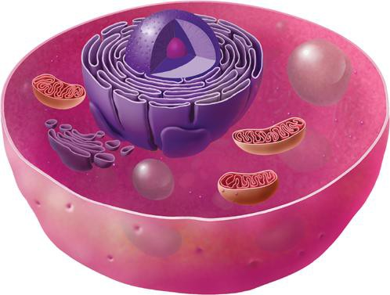

22.

23.

24.

25.

26.

Animal Cell
mitochondria
nucleus
cell membrane
vacuole
cytoplasm

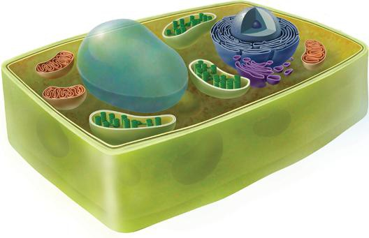

27.

28.

29.

31.

32.
30.

33.

 | Animal Cell
mitochondria | cell wall | nucleus
cell membrane | vacuole | cytoplasm
 | chloroplast

